Business Letter Assignment ENG Final Draft Business Letter Submission Deadline:
Final Draft Setup Requirement:
- Polished, properly formatted, one-page letter
- Single-spaced
- 11 or 12-point Times New Roman font
WHAT: Write a 1-page business letter appropriate for the professional workplace.
HOW: The business letter will be addressed to a classmate and will
- capture the classmate’s attention;
- describe (briefly) the steps of process writing;
- present a persuasive argument to motivate the classmate to use steps in process writing in
development of his/her written assignments throughout the semester;
- demonstrate your knowledge of process writing, your ability to craft a professional letter, and
your skill at persuading a reader to action.
WHY: This assignment strengthens your ability to analyze, synthesize, and evaluate main ideas in production of a common communication document. It demonstrates writing as a process that requires substantive revision, and it promotes communication skills aimed at a specific audience about a particular subject for a defined purpose while advancing your understanding of your strengths as a writer of persuasive business materials.

An example of a business letter
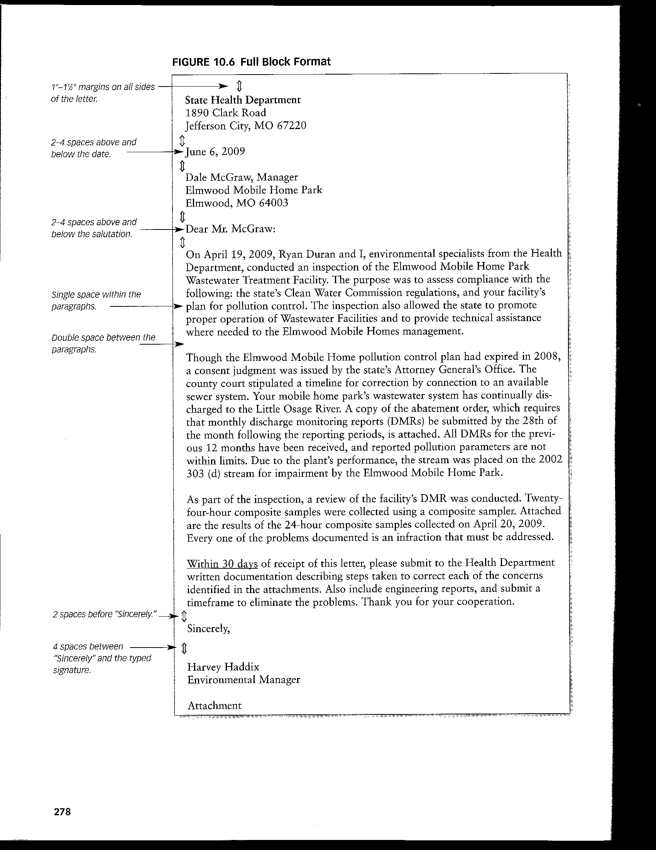

Check list of a business letter

